Final Assessment-Alternative Assessment
Semester | 202520 | Division | CIS
Assessment title in Syllabus | Final_Project_Portfolio | Program | Bachelor of Information Technology/ Bachelor of Information Systems
Course Code | CDS 2413
Course Title | INTRODUCTION TO DATA SCIENCE
Course Instructor |  | CRN | 23674
Assessment | Project Deliverable 1 – Data Analysis Report | Submission Date | Week 6
Student Declaration:
Academic Integrity Statement
In accordance with the HCT Academic Integrity Policy
• Students are required to refrain from all forms of academic integrity breaches as defined and explained by HCT.
• A student found guilty of having committed acts of academic integrity breach(es) will be subject to the relevant sanctions as outlined by HCT.
إفادة النزاهة الأكاديمية
وفقًا لسياسة كليات التقنية العليا للنزاهة الأكاديمية
• على الطلبة الإلتزام بلوائح وقواعد النزاهة الأكاديمية، كما هو مبيّن وموضح في السياسات والإجراءات الخاصة بكليات التقنية العليا.
• في حالة ارتكاب الطالب أي شكل من أشكال الإخلال بالنزاهة الأكاديمية، سيتعرض الى العقوبات الموضحة في السياسات ذات الصلة.
This assignment is entirely my/our own work except where I have duly acknowledged other sources in the text and listed those sources at the end of the assignment. I have not previously submitted this work to the HCT, or any other entity. I understand that I may be orally examined on my submission.

Student HCT ID(s): | H00468893 | H00534370 | H00495372 | H00
Student Name(s): | Naema Hussain | Aaesha Khaled | Shaikha Ali
Student Signature
Chatbot (e.g. ChatGPT) statement
This submission allows you to use AI generated tools, but the prompt used must be stated and the response must be in red font. Include References to ChatGPT.

Instructions

Remove instructions and hints from the template before submitting the final report to BBLearn.

CLO1: Introduction and Data Wrangling (5 Points)

Purpose of Data Analysis (1 point)

<< Define the purpose of data analysis for the chosen dataset >>

The purpose of analyzing the Car Price Prediction dataset is to build a predictive system that estimates the selling price of used cars based on their features such as year, mileage, fuel type, transmission, and engine specifications.

Data analysis is useful for:
- Buyers identify fair market prices
- Sellers set competitive prices
- Businesses improve car listing platforms

Type of Programming (1 point)

<< Identify and Justify the type of programming used for data analysis>>

Python Programming (Data Science Approach)
Python is used because it supports powerful libraries such as:
- Pandas (data handling)
- NumPy (numerical operations)
- Matplotlib & Seaborn (visualization)
- Scikit-learn (machine learning)

Type and Purpose of ML algorithm (1 point)

<< Identify the type and purpose of the machine learning algorithm to be implemented for the chosen dataset >>

Type:

Regression Algorithm for Supervised Learning

Goal:

We employ a regression algorithm like this since the target variable (car price) is numerical:

Regression Linearity

Regressor for Decision Trees

The Random Forest Regressor

Predicting the cost of a car using independent variables is the aim.

Identify the Varaibles (1 point)

<< Identify and Justify the independent and dependent variables for the chosen dataset>>

Dependent Variable
The dependent variable in this project is: Selling_Price
This is the variable we aim to predict. Its value depends on several other characteristics of the car.

Independent Variables
The independent variables include:
- Year
- Present_Price
- Kms_Driven
- Fuel_Type
- Transmission
- Owner

Sampling (1 point)

<< Will you do the sampling? Identify and Justify the type of sampling to be used for the chosen dataset>>

Sampling

Yes, sampling will be performed in this project to analyze a representative subset of the dataset while reducing computational complexity.
Two sampling techniques are used:
Random Sampling:
A random sample of 150 records is selected where each observation has an equal chance of being chosen. This method reduces bias and ensures fair representation of the dataset.
Systematic Sampling:
Systematic sampling selects observations at regular intervals across the dataset. This ensures that the sample is evenly distributed and covers the entire dataset.
Using both methods allows comparison and ensures that the selected sample represents the overall population accurately.

CLO2: Descriptive, Exploratory and Statistical Analysis (10 Points)

Purpose of Descriptive Analysis (1 point)

<< Justify why you want to perform the descriptive analysis for the chosen dataset>>
The analysis of the Selling_Price variable indicates noticeable variability in car prices. The mean price is slightly higher than the median, suggesting a positively skewed distribution. This means that a small number of high-value cars increase the overall average price.
The standard deviation confirms that prices vary significantly depending on vehicle specifications. The wide range between minimum and maximum prices reflects the diversity of vehicles included in the dataset, from lower-cost vehicles to premium models.
These findings highlight the importance of applying regression models to capture complex pricing patterns.

Script for Descriptive Analysis (1 point)

<< Create a script to develop a Python function for descriptive statistics. The input for the function should be the sample and the field to perform the descriptive statistics>>

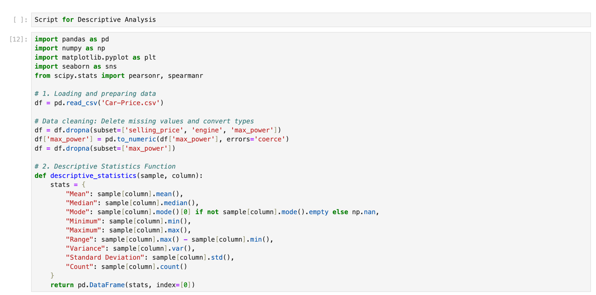

Random Sampling (1 point)

<< Create a program to random sampling of size 150 and find the descriptive statistics for the dependent variable from the sample [Apply the descriptive function which you created>>

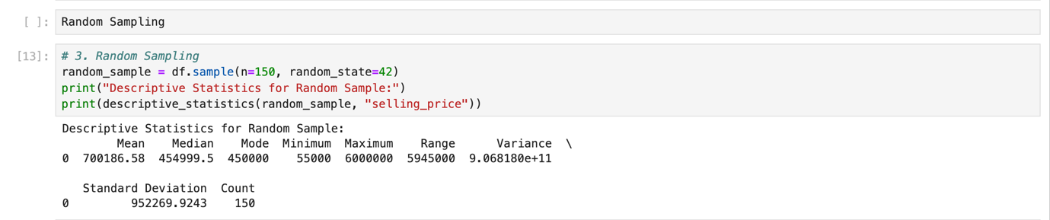

Systematic Sampling (1 point)

<< Create a script for systematic sampling by giving certain conditions and finding the desc stat for the dependent variable from the sample [Apply the descriptive function which you created>>

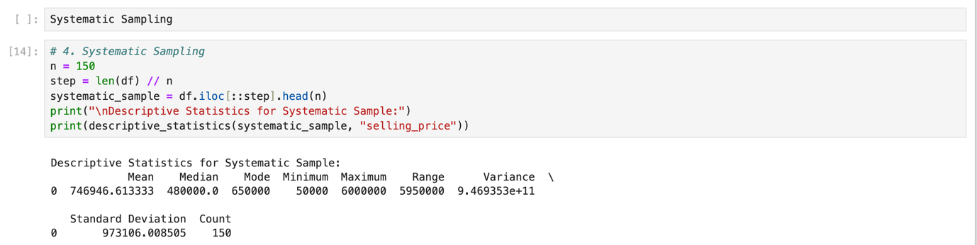

Descriptive Statistical Report (1 point)

<< Create a detailed descriptive statistics report about the dependent variable of the chosen dataset>>

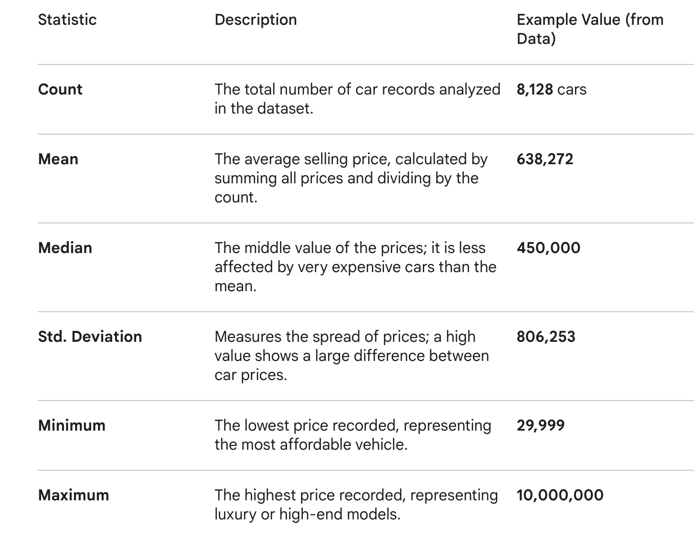

Visualisation through Various Charts (2 points)

- << Visualize the dependent variable by the Graph/Chart of the following using Python Program:
  - Scatter plot
  - Box Plot
  - Histogram
  - Heat Map
Hint: Use Matplot or Ski-learn library>>

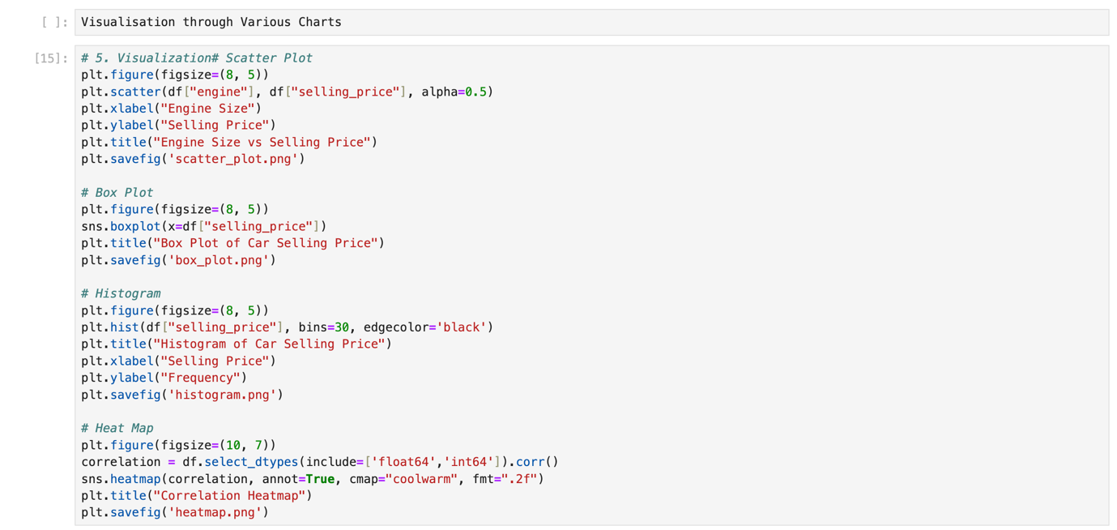
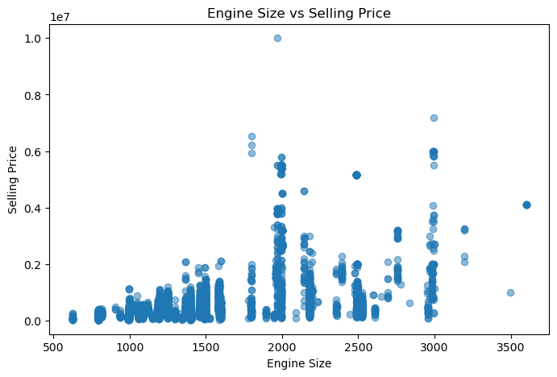

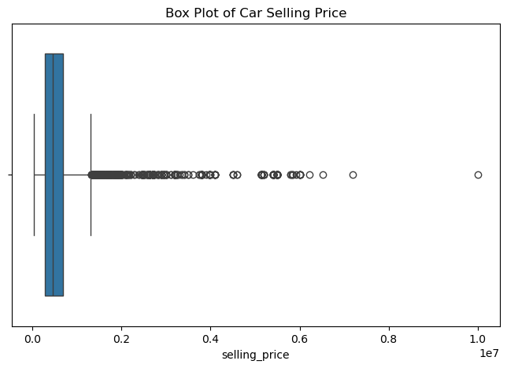

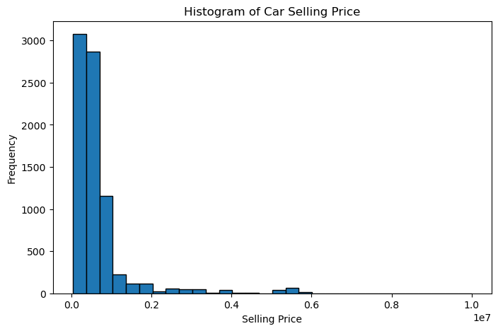

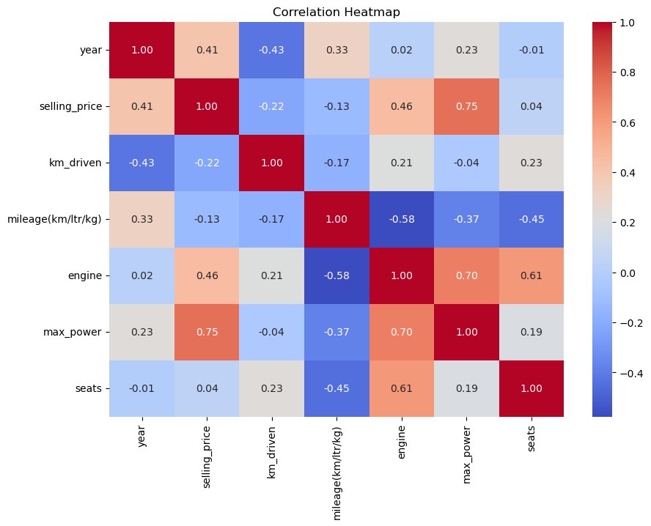

Hypothesis Test (1 point)

<< 8. Perform the hypothesis test to find the correlation (Pearson and Spearman for numerical variable and chi-square test for categorical variable) between the independent variable and the dependent variable.
Note: If you have more than one independent variable, then choose any one of the independent variables.>>

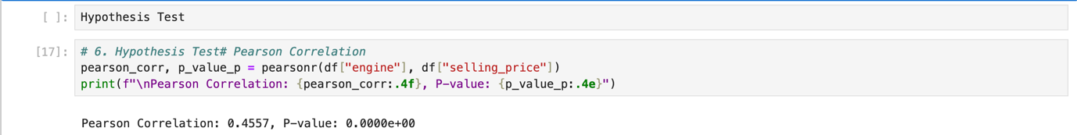

# H0: There is no correlation between Engine Size and Car Price.
H1: There is a significant correlation between Engine Size and Car Price.
Significance level α = 0.05
If p-value < 0.05 → Reject H0.

One Sample T-test (2 points)

<< Assess the performance of the dependent variable to know whether the sample is representative of the normal population by a one-sample t-test..>>

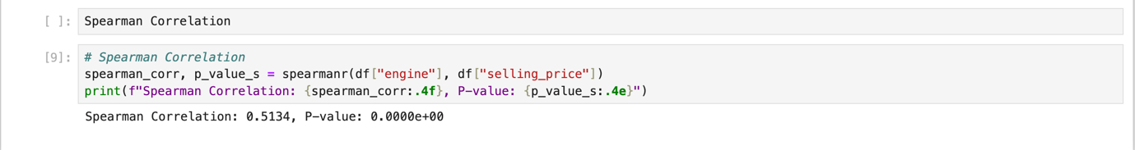

# If p-value < 0.05 → Reject H0 and conclude that the sample mean is significantly different from the population mean.

End of Documentation.

